Consolidation of soft soil by means of vertical drains: field and laboratory observations

I. B. Gratchev¹, C. Surarak², A. Balasubramaniamand³, and E. Oh³

¹Griffith School of Engineering, Gold Coast Campus, Griffith University, Parklands Drive, Southport, QLD, 4222, Australia; PH (61-7) 555-27686; FAX (61-7) 555 28065; email: ivangratchev@gmail.com
²Formely Doctoral Student, Griffith School of Engineering, Gold Coast Campus, Griffith University, Parklands Drive, Southport, QLD, 4222, Australia
³Griffith School of Engineering, Gold Coast Campus, Griffith University, Parklands Drive, Southport, QLD, 4222, Australia

Abstract

Prefabricated vertical drains (PVD) in combination with pre-loading have become a popular method of soil improvement in Australia as it provides an effective and low cost solution to the soft soil problems. A few large-scale trial embankment tests have been performed in the Brisbane and Sunshine Coast areas in the past decades to explore the feasibility of using PVD techniques for construction of high speed motorways on soft soil foundations in Queensland. Although satisfactory performance was observed in several trials, the effectiveness of vertical drains was not fully assessed as the varying geologic conditions as well as the design features of the embankment trial could have affected the field data. This papers seeks to provide laboratory data that can be used for assessment of the effectiveness of ground improvement methods, thus minimizing the unfavorable outcome from large-scale field projects. The experimental program was designed to study the effect of vertical drains on settlements of soil under different stress levels. It was found that the process of consolidation occurred more rapidly when vertical drains were installed, however it can vary depending on the size of drain and the smear effect. In addition, data from a large-scale trial at the Sunshine Coast motorway were reviewed to provide a better understanding of the effect of PVDs on the improvement of soft soil characteristics.

Keywords: prefabricated vertical drains, soft clay, Rowe Cell, settlement, ground improvement

INTRODUCTION

In recent years, the rapid increase in population of the coastal Australia has resulted in the need to develop infrastructure in areas with undesirable ground conditions such as soft clays. Being extremely compressible, these soils present significant challenges for infrastructure design and construction as they have the tendency to sustain high excess-pore water pressures during static loading in the absence of appropriate ground improvement.

To solve this problem, a good deal of research has been conducted in the past few decades to develop effective methods of soil improvement. Several techniques have been proposed, including sand drains and stone columns, however the combination of preloading method with prefabricated vertical drains seems to have received the most attention from the geotechnical community (Balasubramaniam et al. 1984, Hansbo 1979, Tan et al. 1987, Bergado et al. 2002) as it provides a low cost solution for improving the performance of thick deposits of soft clays.

Although a few analytical solutions and computer codes to predict settlements of soft soil with PVDs have been developed and refined in the past few decades (Indraratna et al. 2003), it still remains a challenging task to select a method of soil improvement that will produce the most desirable outcome for a specific site as there are a few variables including geologic conditions, spacing between PVDs, and the smear effect that need to be considered. As a result, there are several case studies in which drains did not perform to expectations, as has been documented in technical papers (Robertson 1984, Litwiniwicz 1988, Ameratunga et al. 2010a). For example, Wijeyakulasuriya et al (1999) presented the results of trial embankments on soft sensitive marine clays constructed along the eastern coast of Queensland. The authors reported that the use of drains in these soil conditions was not effective and suggested that such a soil improving technique should only be used with caution for soils with similar geotechnical properties. Recently, Ameratunga et al. (2010b) analysed the results from large-scale trail tests at the Port of Brisbane, Queensland, where different drain spacing from 1.0 m to 1.4 m was used, and reported that “a definite reduction in performance was observed for the closer 1.0 m triangular spacing” mostly due to the greater effect of smear when the drains were closely spaced.

To avoid such undesirable results, the effectiveness of PVDs needs to be assessed for different site conditions, a challenging task that would involve a number of costly and time-consuming field trials. In contrast, relatively inexpensive laboratory tests including oedometer and large-scale consolidation experiments can be considered as a valid alternative. Although, such tests tend to underestimate the consolidation characteristics of soft clays (Balasubramaniam et al. 2010), they still produce valuable information about the geotechnical properties of soil within a reasonable time frame. In addition, a few researchers have used laboratory tests to study the smear effect due to installation of PVDs. For example, Bergado et al. (1991) used a large-scale consolidation test apparatus with an inner diameter of 45.5 cm and the height of 92 cm to study the effect of smear zone due to installation of a PVD on settlement of soft soils. Indraratna and Redana (1998) employed a large-scale consolidation apparatus with a diameter of 45 cm and the height of 95 cm to study the behavior of soft clay with a sand drain. Almeida et al (2001) developed a special oedometric consolidation cell with the sample diameter of 12.5 cm to study the effect of vertical drains of different size on the settlement of soft clay. Although the aforementioned studies have provided useful insights into the process of soil consolidation, it still remains unclear whether laboratory tests can be used to assess the effectiveness of ground improvement techniques. This study seeks to shed light on this matter by providing laboratory data obtained from a series of Rowe Cell tests regarding the performance of PVDs during soft soil consolidation.

In this study, a conventional Rowe Cell apparatus with a diameter of 25 cm was employed to study the consolidation characteristics of dredged mud. Vertical drains of 8.3 mm and 16.5 mm in diameter were used in these tests to better understand the effect of drain size and spacing on the settlement of soil. A special testing procedure was designed to evaluate the effect of smear zone on the time of consolidation. Finally, the obtained results were discussed in the light of the data from a large-scale trial performed at the Sunshine Coast motorway, Queensland, where different spacing between PVDs was used.

laboratory rowe cell tests

Soil properties

The dredged mud from a construction site at the Port of Brisbane (PoB) was kindly provided by the PoB authorities. The geotechnical properties of this soil have been studied by Ameratunga et al (2010b), who reported that the liquid limit (LL) of this mud can widely range from 40 to 80. The soil samples tested in this work had a liquid limit (LL) of about 62, and a plasticity index (PI) of 29.

Experimental procedure

A conventional Rowe Cell apparatus with a diameter of 250 mm was employed in this research to study the effect of vertical drainage on the consolidation characteristics of soft soil. All the specimens for Rowe Cell tests were prepared from slurry. First, an oven-dry soil was mixed with water to form an uniform slurry with a moisture content of 70%. A vertical drain was placed in the middle of the cell, fixed at the bottom, and kept upright while the slurry was placed inside. Such a test procedure was assumed to produce specimens with no smear effect from installation of PVD. Vertical drains with a diameter (d_{w}) of 8.3 mm and 16.5 mm were made of geofabric to provide a path for water flow during testing. Considering that the process of consolidation occurs across the whole specimen with a diameter (d_{e}) of 250 mm, the n ratio, which is defined as n=d_{e}/d_{w}, for the tests with vertical drains was about 30 and 15, respectively. Overburden stress was then applied in increments of 12.5, 25.0, 50.0, and 100.0 kPa. The drainage of water was permitted at the top and bottom of the specimen. Each stress increment continued until 90% consolidation was attained.

To study the smear effect, a different test procedure as described below was used. First, the slurry was placed in the cell, and a load of 12.5 kPa was applied to the sample until 90% consolidation was reached. Then, the sample was unloaded, the top plate of the Rowe Cell was open, and a vertical drain of 16.5 mm in diameter was installed in the middle of the sample by using a specially designed mandrel. After that, the Rowe Cell apparatus was assembled again, and the same load of 12.5 kPa was applied and kept for one day before proceeding to the next stress increment.

Results of Rowe Cell tests

Results from a series of Rowe Cell tests are presented in Figs. 1 and 2. In Fig. 1, the data of settlement against time for three different cases are shown: 1) no drain – where no drainage was used; 2) with a vertical drain of 8.3 mm (n ≈ 30); and 3) with a vertical drain of 16.5 mm (n ≈ 15). It is evident from this figure that a faster settlement rate throughout the test was observed for the specimens with drainage compared to that with no vertical drain. Also, when the drain of a larger size (16.5 mm) was used, the settlement occurred more rapidly than in the test with a vertical drain of 8.3 mm. As the n values of 15 and 30 are typically referred to the drain spacing of 1 m and 2 m in the field, it can be inferred from the results in Fig. 1 that the process of consolidation should occur faster when the spacing is closer. Although these results are in agreement with theoretical solution, they may not be true when applied to the field conditions as no smear effect was considered.
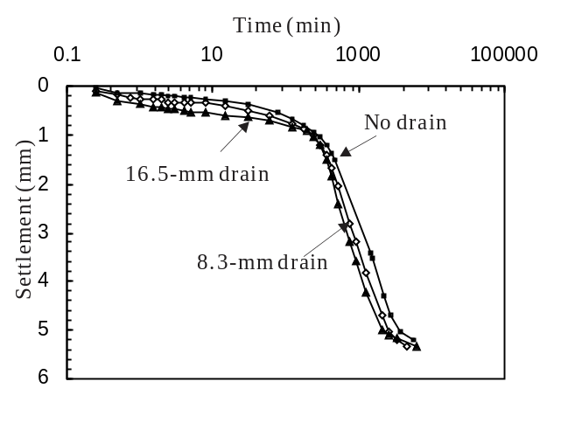
Figure 1. Results of Rowe Cell tests plotted as settlement against time.

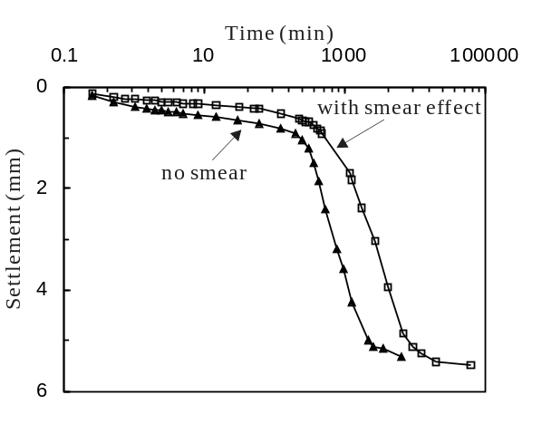
Figure 2. Results of Rowe Cell tests showing the effect of smear zone.

Figure 2 shows the effect of smear zone on the settlement of soil with a vertical drain of 16.5 mm by comparing the results from tests on soil specimens with and without the smear zone. As can be seen, the smear effect may significantly increase the time of consolidation.

Large-scale field trial at sunshine motorway, queensland

Site description and soil conditions

It is interesting to compare results from the laboratory tests with data obtained from large-scale field projects to clarify whether laboratory tests can assess the effectiveness of ground improvement techniques. For this purpose, results from field trial at the Sunshine Coast Motorway was reviewed and discussed below.

In 1992, Queensland Department of Main Roads was commissioned to perform and monitor a fully instrumented trial embankment in Area 2A of the Sunshine Motorway, South East Queensland with the purpose of assessing the effectiveness of different ground improvement techniques (Rankine et al. 2005). Geotechnical site investigation revealed the presence of up to 11 m thick layer of soft, extremely compressible, saturated marine clays of high sensitivity (Surarak 2005).The natural moisture content of this clay varied from 80 to 100%, which was significantly higher than its liquid limit (LL) which was approximately 60%.
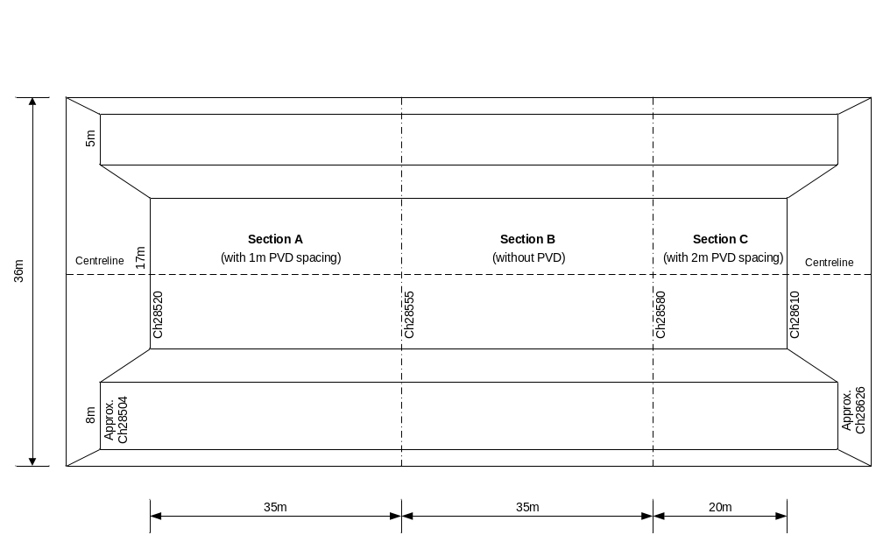

Figure 3. A schematic plan of trial embankment at the Sunshine Motorway (from Surarak 2005).

The trial embankment which was approximately 90 m long and 36 m wide included three sections, namely A, B, and C as shown in Fig. 3. In Sections A and C vertical drains were installed in a triangular grid pattern but with different spacing: 1 and 2 m, respectively. Section B was designed to study the settlement of soft clay without ground improvement (without PVD).

Settlements at different sections

The process of consolidation was monitored for a long period of time, and data of settlement, pore water pressure, and radial deformations were recorded for each section. Figure 5 shows the rate of settlement for Sections A (with 1-m PVD spacing), B (without PVD), and C (with 2-m PVD spacing). It is evident from this figure that the rate of settlement was greater for Sections A and C, where PVDs were used. Figure 5 also indicates that although different spacing between PVDs was used in Sections A and C, the overall performance of vertical drainage seems to be very similar with the rate of settlement being almost the same.

Discussion

Considering that the performance of vertical drains in the Rowe Cell tests seems to correlate with that observed in the field large-scale trail at the Sunshine motorway, it can be suggested that laboratory tests can provide a good indication of the performance of PVDs in the field, and assess the effectiveness of ground improvement techniques. Moreover, as laboratory tests are relatively inexpensive they can be used at the preliminary stage to suggest the most effective method of ground improvement for the specific site conditions. However, it is noted that more data are necessary support this assumptions and clarify the outcomes of this study.

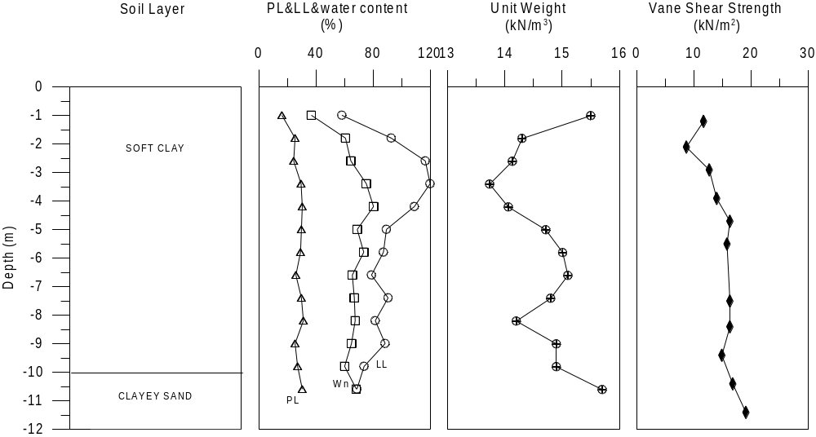

Figure 4. Geotechnical properties of soft clay at the trial embankment. PL-plastic limit; LL-liquid limit. (from Surarak 2005).

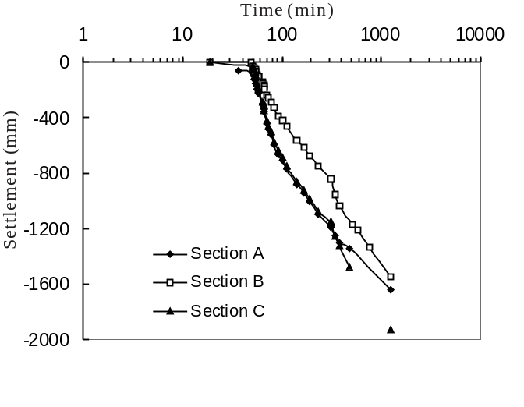
Figure 5. Variation of settlement with Time along the centreline observed for Sections A, B, and C.

conclusion

In this study, results from laboratory Rowe Cell tests and field large-scale trial experiment were analyzed and discussed. Based on the obtained results, the following conclusions can be drawn:

- Result of Rowe Cell tests indicates that the rate of settlement may increase when a vertical drain of a large size is used;
- The smear effect can significantly decrease the rate of settlement;
- Comparisons between results of Rowe Cell tests and large-scale trial at the Sunshine motorway suggest that laboratory tests can be used to assess the effectiveness of ground improvement techniques.

ACKNOWLEDGEMENTS

The authors thank Mr. Peter Boyle from Port of Brisbane Pty Ltd for his help in obtaining soil samples for this research. This research was supported by the NRG grant from Griffith University.

REFERENCES

Almeida, M., Santa Maria, P., Martins, I., Spotti, A., and Coelho, L. (2000). “Consolidation of a very soft clay with vertical drains.” Geotechnique, 50 (6), 633-643.
Ameratunga, J., Boyle, P., Bok, C. and Bamunawita, C. (2010a). “Port of Brisbane (PoB) clay characteristics and use of wick drains to improve deep soft clay deposits.” The 17th Southeast ASIAN Geotechnical Conference, Taiwan.
Ameratunga, J., De Bok, C., Boyle, P., and Berthier, D. (2010b). “Ground improvement in Port of Brisbane (PoB) clay.” ISSMGE Bulletin, 4 (2), 28-54.
Balasubramaniam, A.S., Chandra, S., and Bergado, D.T. (1984). "Recent Developments in Ground Improvement Techniques." Balkema Publishers, The Netherlands, pp 587.
Balasubramaniam, A., Cai, H., Zhu, D., Surarak C., and Oh, E. (2010). “Settlements of Embankments in Soft Soils.” The 17th Southeast ASIAN Geotechnical Conference, Taiwan.
Bergado, D. T., Asakami, H., Alfaro, C., and Balasubramaniam, A.S. (1991). “Smear effects of vertical drains on soft Bangkok clay.” Journal of Geotechnical Engineering, 117 (10), 1509-1530
Bergado, D. T., Balasubramaniam, A. S., Fannin, R. J. And Holtz, R. D. (2002). “Prefabricated Vertical Drain (PVD) on Soft Bangkok Clay.” Canadian Geotechnical Journal, 39 (4), 304-315.
Hansbo, S. (1979). “Consolidation of clay by band-shaped prefabricated drains”, Ground Eng., 12 (5), 16-25.
Indraratna, B., and Redana, I. W. (1998). “Laboratory determination of smear zone due to vertical drain installation.” Journal of Geotechnical and Geoenvironmental Engineering, 124 (2), 180–184.
Indraratna, B., Bamunawita, C., Redana, I., and McIntosh, G. (2003). “Modelling of prefabricated vertical drains in soft clay and evaluation of their effectiveness in practice.” Journal of Ground Improvement, 7 (3), 127-138.
Litwinowicz, A. and Smith, I.K. (1988). “A brief review of geotechnical aspects and monitoring of Gateway Arterial roadworks north of the Brisbane River.” Proceedings of 5th Australia - New Zealand Conference on Geomechanics, Sydney, 298-304.
Rankine, B., Sivakugan, N., and Wijeyakulasuriya, V. (2005). “Observed and predicted behaviour of clay foundation response under the Sunshine Motorway trial embankment.” Proceedings of the 16th International Conference on Soil Mechanics and Geotechnical Engineering, Osaka, Japan, 951-954.
Robertson, N.F. (1984). “The use of monitoring for roadworks construction control”, Proceedings of 4th Australia – New Zealand Conference on Geomechanics, Perth, 321-328.
Surarak, C. (2005). “Characterisation of Southeast Queensland soft clay deposits in Sunshine motorway.” Master Thesis, Griffith University, p. 121.
Tan, S.A., Karunaratne, G.P., Lee, S.L., and Choa, V. (1987). “Design of drains and surcharge in reclamations.” Soils and Foundations, 27 (4), 88-98.
Wijeyakulasuriya, V., Hobbs, G. and Brandon, A. (1999). “Some experiences with performance monitoring of embankments on soft clays.” Proceedings of 8th ANZ Conference on Geomechanics, Hobart, pp 783–788.

